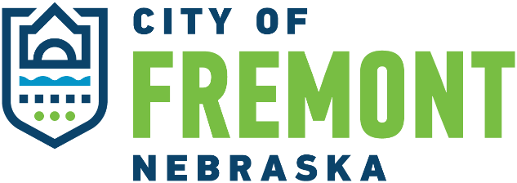

BUILDING CODE ADVISORY and APPEALS BOARD MEETING

THURSDAY, JUNE 27, 2024
City Council Chambers, 400 East Military Avenue, Fremont NE
2:00 P.M.

AGENDA

- Call to Order.

- Roll Call.

- Building Inspector Opening Comments

New Business

- Discuss appointment of a board chair.

- Discuss appointment of a board vice-chair.

- Discuss the adoption of the 2023 National Electric Code (NEC).

- Discuss current local Fremont amendments to NEC.

- Discuss proposed Fremont amendment to NEC.

- Discuss the procedure for citizens to appeal a Building Department code interpretation.

- Adjournment.

This meeting was preceded by the agenda displayed in the lobby of the Municipal Building and posted online at www.fremontne.gov IN ACCORDANCE WITH THE NEBRASKA OPEN MEETINGS ACT, a copy of which is posted continually in the council chambers for public inspection, and said meeting is open to the public. A copy Of the agenda was ALSO kept continually current and available to the public IN the PRINCIPAL office of the DEPARTMENT OF building, 400 East Military AVENUE. The building code advisory and appeals board department reserves the right to adjust the order of items on this agenda.

